REPORT TO: PENSION SUB-COMMITTEE OF THE CITY GOVERNANCE COMMITTEE & PENSION BOARD – 22 SEPTEMBER 2025
REPORT ON: TAYSIDE PENSION FUND RISK REGISTER
REPORT BY: EXECUTIVE DIRECTOR OF CORPORATE SERVICES
REPORT NO: 253-2025
- PURPOSE OF REPORT

The Sub-Committee is asked to approve the Quarterly Risk Register for Tayside Pension Fund.

- RECOMMENDATIONS

The Sub-Committee is asked to approve the Quarterly Risk Register for Tayside Pension Fund, noting no change from previous quarterly report.

- FINANCIAL IMPLICATIONS

There are no financial implications other than those highlighted in the risk register.

- INTRODUCTION

The Local Government Pension Scheme Management and Investment of Funds (Scotland) Regulations 2010 requires funds to state the extent to which they comply with guidance given by the Scottish Ministers.

The Scottish Ministers guidance refers to the six revised principles on investment decision making contained within CIPFA publication "Investment Decision Making and Disclosure in the Local Government Pension Scheme: A Guide to the Application of the Myners Principles" (December 2009).

Principle 3: Risk and Liabilities (paragraph 98) states that "The annual report of a pension fund should include an overall risk assessment in relation to each of the fund’s activities and factors expected to have an impact on the financial and reputational health of each fund. This could be done by summarising the contents of a regularly updated risk register. An analysis of the risks should be reported periodically to the committee, together with necessary actions to mitigate risk and assessment of residual risk".

The initial Tayside Superannuation Funds Risk Register (Article III of the Minute of Meeting of the Superannuation Sub-Committee of the Policy and Resources Committee of 21 February 2011, Report No 114-2011 refers) requires conformity with the Statements of Investment Principles for the Tayside Pension Fund.

In 2021, an internal audit review of Risk Management and Regulatory Compliance was completed, and the findings were reported to the Pension Sub-Committee & Board (Article IX of the Minute of Meeting of the Pension Sub-Committee of the Policy and Resources Committee & Pension Board of 21 March 2022, Report No 87-2022 refers). The review suggested the following changes be made to the risk register:

- Update of current risk descriptions to use cause, event and consequence format
- Addition of risks not specified within current risk register
- Implementation of a revised risk scoring matrix specific to Tayside Pension Fund

All risks and controls have been reviewed and rescored accordingly.

- POLICY IMPLICATIONS

This report has been subject to the Pre-IIA Screening Tool and does not make any recommendations for change to strategy, policy, procedures, services or funding and so has not been subject to an Integrated Impact Assessment. An appropriate senior manager has reviewed and agreed with this assessment.

- CONSULTATIONS

The Chief Executive and Head of Democratic and Legal Services have been consulted in the preparation of this report.

- BACKGROUND PAPERS

None.

PAUL THOMSON
EXECUTIVE DIRECTOR OF CORPORATE SERVICES 15 September 2025

  Quarterly Risk Report  Report Type: Tayside Pensions Fund Risks Report  Report Author: Executive Director of Corporate Services  Generated on: 20 August 2025 | Pentana Risk Matrix  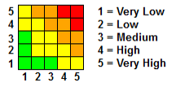

Risk Type & Title | Causes | Impact | Consequence | Inherent Risk | Controls | Residual Risk (Previous Quarter) | Residual Risk (Current)
Pension Administration  (Risk appetite - minimalist)  - Failure to process pension payments and lump sums on time | - Non-availability of pension / payroll systems  - Resource unavailable  - New staff undertaking duties  - Increased workload  - Failure to gain relevant information from employers to enable processing | - Processing delays  - Processing errors  - Retiring members will be paid late  - Reputational risk for the Fund  - Breach of statutory requirements | - Financial implications for members.  - Loss of stakeholder confidence.  - Financial cost to the fund if interest has to be paid to members.  - Regulatory action | 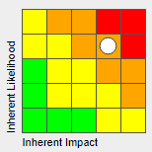 | - Regular update & maintenance of Altair & Resourcelink  - Standardised processes & independent review of calculations  - Sufficient staff cover arrangements  - Task prioritisation  - Contingent measures to prevent financial detriment | 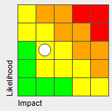 | No change
Funding - Employer related  (Risk appetite - cautious)  - Failure to collect and account for contributions from employers and employees on time | - Non-availability of financial system (Fund and employer)  - Resource unavailable  - New staff undertaking duties  - Failure to communicate with employers effectively  - Failure of employer to provide required information  - Failure of employer to make financial settlement | - Adverse audit opinion  - Breach of statutory requirements  - Knock on effect on reporting requirements  - Financial impact as insufficient cashflow to meet monthly pension payments without unplanned sale of assets | - Requirement for report of regulatory breach & subsequent action if required  - Potential delays to employers' FRS17 year-end accounting reports  - Loss of stakeholder confidence  - Recovery / legal action required  - Opportunity cost of lost investment income | 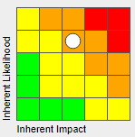 | - Robust maintenance and update of Resourcelink and Authority Financials systems  - Sufficient staff cover arrangements  - Staff training and checking of work.  - Ongoing employer communication to ensure they understand responsibilities to pay by the 19th of the month.  - Contribution tracker system  - Introduction of employer contribution payment flexibility within financial year (subject to agreement) |  | No change
Funding - Liquidity  (Risk appetite - averse)  - Insufficient funds to meet liabilities as they fall due | - Contribution levels are inadequate  - Contributions  - Investment strategy fails to deliver adequate returns  - Significant changes in member profile (i.e. rapid maturing of fund liabilities)  - Significant increases in actuarial assumptions (i.e. longevity. | - Rise in employer contribution rate required  - Unplanned asset sales required to meet  - Revision of Funding and Investment strategies required | - Inability to meet overall strategic objectives  - Immediate cash injections would be required from employers by means of contributions  - Reduced funding levels  - Lost investment income from unplanned asset sales  - Transaction costs associated with changing strategies | 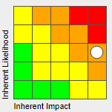 | - Funding Strategy Statement  - Investment Strategy  - Ongoing advice from investment consultants, etc.  - Suitable policies & strategies in place to prevent  - Regular monitoring of asset / liability valuations  - Triennial actuarial valuations | 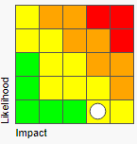 | No change
Operational  (Risk appetite - minimalist)  - Inability to maintain service due to loss of main office, computer system or staff | - Fire, bomb, flood, etc.  - Staff unable to access office (i.e. public health restrictions)  - IT system / network outage | - Temporary loss of service provision.  - Delayed payments & processing  - Retiring staff will be paid late  - Reputational risk for the Fund  - Breach of statutory requirements | - Financial implications for members.  - Loss of stakeholder confidence.  - Financial cost to the fund if interest has to be paid to members.  - Regulatory action | 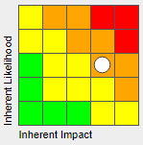 | - DCC business continuity plan (top priority)  - Contractual agreement with system provider  - Daily back up and contingent procedures  - Back-up server located in different building  - 100% staff remote working capabilities | 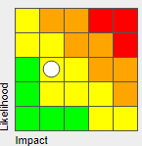 | No change
Operational  (Risk appetite - minimalist)  - Loss of funds through fraud or misappropriation | - Fraud or misappropriation of funds by staff/employer/3rd party service provider | - Financial loss to the fund  - Reputational risk for the Fund  - Adverse audit opinion  - Breach of statutory requirements  - Enforcement action | - Requirement for report to regulator & subsequent action if required  - Criminal investigation  - Loss of stakeholder confidence  - Recovery / legal action required | 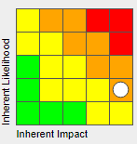 | - Internal and external audit regularly test that appropriate controls are in place and working effectively.  - Regulatory control reports from investment managers, custodian, etc are also reviewed by audit.  - Due diligence carried out when a new manager is appointed.  - Reliance also placed on Financial Conduct Authority registration & requirements. |  | No Change
Funding - Employer related  (Risk appetite - cautious)  - Employers unable to participate in scheme | - Employer liabilities increase disproportionately as a result of changed member profiling  - Employer liabilities increase disproportionately as a result of external factors (i.e. change in bond yields)  - Reduced asset values in relation to liabilities due to external factors | - Employers unable to maintain contributions  - Employers exit from fund  - Employer cannot meet liabilities on exit | - Inability to meet overall strategic objectives  - Financial loss to fund, triggering asset sales to meet pension payments  - Fund profile changed as a result of employer exit  - Insolvency of employer  - Recovery of liabilities in liquidation | 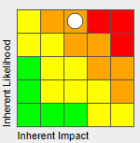 | - Full Actuarial Valuation undertaken every 3 years (employers advised of liability)  - Funding Strategy enables exit at minimum risk.  - Independent covenant and financial settlement assessment on affordability  - Employer contribution payment flexibility within financial year (subject to agreement)  - Employer / fund communications and relationship management | 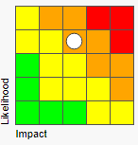 | No Change
Funding - Investment  (Risk appetite - open)  - Significant rises in employer contributions due to poor/negative investment returns | - Poor economic conditions  - Inappropriate investment strategy  - Poor selection / performance of investment managers | - Financial impact as a result of poor/negative investment returns  - Revision of investment strategy required  - Dismissal of investment managers | - Inability to meet overall strategic objectives  - Reduced funding level  - Increased contributions required  - Transaction costs on change of strategy or investment manager | 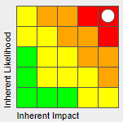 | - Performance & funding levels monitored on an ongoing quarterly basis  - Investment & Funding strategies reviewed and assessed independently  - Diversified range of investment managers over different asset classes  - 10% asset shock reserve |  | No change
Operational  (Risk appetite - minimalist)  - Failure of global custodian | - Financial collapse of global custodian or failure to safeguard assets or records | - Financial loss to the fund.  - Loss of information required for statutory and accounting purpose | - Inability to meet overall strategic objectives  - Severe service disruption as a result of recovery action  - Statutory breaches | 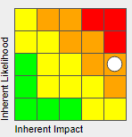 | - Legal agreement with custodian.  - Credit rating monitored on an ongoing basis.  - Regulated by Financial Conduct Authority.  - Assets not on custodian balance sheet. | 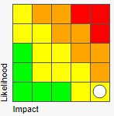 | No Change
Funding - Investment  (Risk appetite - open)  - Failure of Investment Manager | - Substantial decline of global financial market  - Economic factors impacting on asset class  - Under performance of investment manager | - Financial loss to the fund  - Reduced asset returns  - Investment outflows from investment manager portfolio  - Termination of mandate with investment manager | - Inability to meet overall strategic objectives  - Reduced funding level  - Increased employer contribution levels  - Required appointment of alternative investment manager  - Transaction costs associated with change | 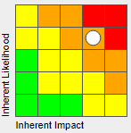 | - Performance monitored on an ongoing quarterly basis.  - Diversified range of asset classes.  - Advice provided by Investment Consultant. | 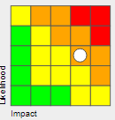 | No Change
Funding - Investment  (Risk appetite - open)  - Equity Risk | - Market sector falls substantially as a result of global economic factors | - Financial loss to the fund | - Inability to meet overall strategic objectives  - Reduced funding level  - Increased employer contribution levels | 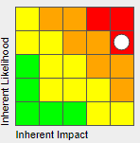 | - Performance monitored on an ongoing quarterly basis.  - Investment strategy with diversified range of asset classes and long-term investment objectives.  - Advice provided by Investment Consultant.  - Fund officers remain in close communications with investment managers  - 10% volatility reserve | 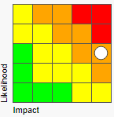 | No Change
Governance  (Risk appetite - minimalist)  - Failure to comply with changes to LGPS regulations and other new regulations / legislation  Specifically:  - GMP  - McCloud  - Pensions Dashboard | - Significant changes to scheme & regulations which staff are unfamiliar with  - Failure in readiness for changes  - Lack of technical expertise / training  - Inadequate procedures / process  - Lack of resources  - Error in interpreting requirements  - IT systems not updated to reflect changed requirements | - Incorrect calculations  - Delays in processing  - Statutory breaches  - Reputational risk | - Financial implications for members.  - Loss of stakeholder confidence.  - Financial cost to the fund if interest has to be paid to members.  - Regulatory action | 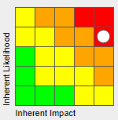 | - Verification process in place within Pensions section  - Staff training  - Audited key processes reviewed prior to significant changes  - Recruitment exercises as required  - Robust system maintenance & upgrade  - Specialist advice used as required to ensure correct interpretation  - Performance monitoring  - Project management for implementation of key changes / exercises | 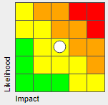 | No change
Governance  (Risk appetite - minimalist)  - Failure to comply with governance best practice  Specifically:  - TPR New Draft Code of Practice  - TPR Good Governance project outcomes | - Failure to implement requirements  - Inadequate processes / procedures  - Inadequate training as to changed requirements | - Breach of statutory requirements  - Sub-standard service to members and employers  - Reputational risk for the Fund | - Regulatory action  - Loss of stakeholder confidence | 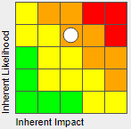 | - Staff training  - Audited key processes reviewed prior to significant changes  - Specialist review and advice |  | No Change
Pension Administration  (Risk appetite - minimalist)  - Failure to provide quality service to members | - Inadequate administration & communication policies  - Lack of resources  - Lack of staff skills / knowledge  - Lack of training  - Ineffective processes & procedures  - Poor communication documentation  - Unanticipated workloads | - Reputational risk for the Fund  - Processing delays & errors  - Late payments  - Sub-optimal decision making  - Reputational risk for the Fund | - Financial implications to members  - Loss of stakeholder confidence | 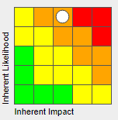 | - Key policies reviewed and updated annually or sooner if required  - Recruitment exercises as required in keeping with statutory requirements  - Ongoing staff training and support  - Key processes audited and reviewed annually  - Communication / documentation reviewed regularly and updated  - Weekly work allocation to prioritise and avoid bottlenecks |  | No Change
Operational  (Risk appetite - minimalist)  - Failure to hold personal data securely | - Insufficient system abilities re security of data  - Sub-standard retention processes & procedures  - Inadequate data retention policy, backup and recovery procedures  - Change of retention requirements | - Data lost or compromised  - Incorrect member records  - Processing delays & errors  - Retiring staff will be paid late  - Reputational risk for the Fund  - Breach of statutory requirements | - Financial impact to members  - Loss of stakeholder confidence.  - Financial cost to the fund if interest has to be paid to members.  - Regulatory action | 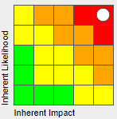 | - Data security system settings & controls  - Data retention policy & processes / back up & recovery procedures |  | No Change
Operational  (Risk appetite - minimalist)  - Cybercrime | - Inadequate system abilities re security of data  - Inadequate controls and security protocol | - Data lost or compromised  - Incorrect member records  - Processing delays & errors  - Retiring staff will be paid late  - Reputational risk for the Fund  - Breach of statutory requirements | - Financial impact to members  - Loss of stakeholder confidence.  - Financial cost to the fund if interest has to be paid to members.  - Regulatory action |  | - Data security system settings & controls  - Data back-up & recovery procedures |  | No Change
Pension Administration  (Risk appetite - minimalist)  - Failure to keep pension records up-to-date and accurate | - Non-availability of pension / payroll systems  - Resource unavailable  - New staff undertaking duties  - Increased workload  - Failure to gain relevant information from employers to enable processing | - Processing delays  - Processing errors  - Retiring members will be paid late  - Reputational risk for the Fund  - Breach of statutory requirements | - Financial implications for members  - Loss of stakeholder confidence  - Financial cost to the fund if interest has to be paid to members  - Regulatory action | 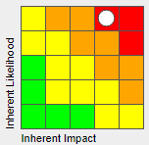 | - System contingency / recovery prioritised  - Service prioritisation / allocation  - Staff training  - Scheduled communications / updates from employers | 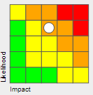 | No Change
Governance  (Risk appetite - minimalist)  - Lack of expertise on Pension Committee, Pension Board or amongst officers | - Lack of training & continuous professional development  - Loss of key individuals | - Detrimental decision making  - Reputational risk for the Fund  - Breach of statutory requirements  - Failure to meet objectives | - Financial loss  - Inability to meet overall strategic objectives  - Increase in employer contribution requirements  - Regulatory action  - Loss of stakeholder confidence | 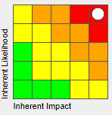 | - Key policies and governance arrangements independently audited and reviewed  - Key officer meets Markets in Financial Instruments Directive (MIFIID) professional investor requirements  - Training & support  - External specialist advice |  | No Change
Governance  (Risk appetite - minimalist)  - Over reliance on key officers | - Loss of key individuals  - Inability to recruit individuals with specialist skills & experience  - Inadequate governance arrangements  - Lack of specialist advisors to support | - Detrimental decision making  - Reputational risk for the Fund  - Breach of statutory requirements  - Failure to meet objectives | - Financial loss  - Inability to meet overall strategic objectives  - Increase in employer contribution requirements  - Regulatory action  - Loss of stakeholder confidence |  | - Key policies and governance arrangements independently audited and reviewed  - Knowledge & experience of staff  - External specialist advice  - Peer support from other LGPS |  | No Change
Governance  (Risk appetite - minimalist)  - Failure to communicate adequately with stakeholders | - Inadequate communication policy  - Inadequate processes & protocols with employers and scheme members | - Scheme members not aware of their rights  - Employers not aware of regulations, procedures, etc.  - Reputational risk  - Breach of statutory requirements | - Sub-optimal decision making resulting to financial detriment of members  - Errors in members calculations  - Loss of stakeholder confidence  - Regulatory action | 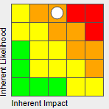 | - Communications policy  - Standard documentation & communications  - Website information  - Standard key processes & protocols  - Employer communications (e mails / info sessions / documentation / guidance  - Adequately trained staff |  | No Change
Funding - Employer related  (Risk appetite - cautious)  - Employer Covenant Risk | - Change in employer actuarial profile which has resulted in significant increase in liability  - Unsuitable guarantee / financial health of employer | - Employers unable to financially provide for exit liability | - Inability to meet overall strategic objectives  - Financial impact on overall funding level  - Remaining employers required to accommodate the shortfall via increased contribution |  | - Government or local authority guarantees, bonds or securities over assets  - Independent covenant review and financial assessments to identify  - Funding strategy to enable exit at minimal risk to remaining employers  - Affordable payment schedule independently assessed |  | No Change
Governance  (Risk appetite - minimalist)  - Risks in relation to use of 3rd party service providers | - Inadequate policy  - Poor due diligence and selection processes  - Poor contract management | - Poor decision making  - Failure of supplier adhering to contractual agreement  - Reputational risk | - Financial detriment to the fund  - Loss of stakeholder confidence |  | - Procurement policy  - Contracts database  - Documented contract management protocol  - Use of national frameworks | 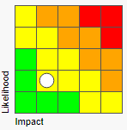 | No change
Funding - ESG  (Risk appetite - cautious)  - Failure to implement ESG Policy (specifically in relation to Climate Change and incoming requirements of TCFD) | - Inadequate policy & practices  - Failing to understand incoming requirements  - Failing to plan and implement changes required  - Lack of knowledge & skills | - Poor decision making  - Non-compliant actions being taken  - Statutory breach  - Reputational risk | - Failing to meet strategic objectives  - Regulatory action  - Loss of stakeholder confidence |  | - Regularly reviewed policies, processes and reporting  - Project plans to meet changing requirements  - Specialist advice as required  - Training |  | No Change

